**Đỗ Văn Hòa – 1801040089 - Lớp 4C18**

# **Tutorial 10: Project Communication Management**

**Exercise 1:**

Research the topic of understanding body language.

+ What are some common body movements that can help you understand how people are really feeling?

+ What does it mean if someone looks up a lot when talking versus looking down or side to side?

+ What does it mean when people cross their arms, touch their noses, or make other common gestures with their bodies?  
+ Perform a role play of common project scenarios, and have people take turns saying something that does not match their body language. For example, someone might say that work is going well on a particular task when it is not.

**Solution**

Body language refers to nonverbal communication that we use to express our emotions and feelings (Cherry, 2019). Even though we do not say, we can still convey our information through our posture, facial expressions and gestures. There are some familiar body movements that help us understand how people are truly feeling:

***Head Tilted to One Side***

A tilted head shows that a person listens attentively, or is interested in what is being shared (examples.yourdictionary.com, 2019).

***Pulling Your Ear***

People often pull one of their ear lobes while attempting to make a choice but seem indecisive. The motion indicates the inability to draw a conclusion.

***Moving your eye direction***

There are various studies mentioning eye direction during lies. For instance, People are pretending or tapping into their imagination as they look up and to the right (Edwards, 2017). When they look up and to the left, they recall or remember something that taps into the brain's memory part. In addition, when someone looks down to their right, it means that they are forming a sensory memory or feeling. If someone is looking down to their left, they are talking to themselves. These indications are fairly helpful to detect whether he or she is telling a lie.

***Cross your arms over the chest***

This body language example may suggest a defensive person. He/she may appear uninterested or a bit angry (Mind Tools Content Team, 2020). It can also indicate that the individual with crossed arms opposes the viewpoints or behaviors of other people with whom they are speaking.

***Rubbing or Touching Your Nose***

It can mean several things when someone touches or rubs their nose. The person may appear untruthful if he/she does it in a conversation. This can be a major obstacle to attain goals. Therefore, it's important that if you see someone else rubbing her nose, you have to be careful not to immediately believe anything that they tell you.

***Stroking Your Chin or Beard***

When someone strokes the chin, he or she conveys critical thoughts. Such a motion is frequently used accidentally when an individual tries to make a decision on a matter. This is indicative of concern and interest

Body language plays a vital role in project scenarios. It will show the level of relationships and communications between you and your partner (or even your boss) (BusinessBalls, 2019). For example, a firm handshake is a good indication showing that you are very confident and regard the other as an important character. However, people sometimes convey their thoughts or sayings that do not match with their body language. In particular, some people often misunderstand that weak handshake is only a behavior that you do not respect, or even underestimate your partner. It is not necessarily true. Many people shake hands weakly on account of several reasons such as their mood, vocation and so on. Artists, musicians, and dancers, for example, are typical examples owning sensitive handshakes.

**Exercise 2:**

Review the following scenarios, and then write a paragraph for each one describing what media you think would be most appropriate to use and why. See Table 10-2 (in the textbook) for suggestions.

* 1. Many of the technical staff on the project come in from 9:30 a.m. to 10:00 a.m., while the business users always arrive before 9:00 a.m. The business users have been making comments. The project manager wants to have the technical people come in by 9:00, although many of them leave late.
  2. Your company is bidding on a project for the entertainment industry. You know that you need new ideas on how to put together the proposal and communicate your approach in a way that will impress the customer.
  3. Your business has been growing successfully, but you are becoming inundated with phone calls and e-mails asking similar types of questions.
  4. You need to make a general announcement to a large group of people and you want to make sure they get the information.

**Solution**

a, for scenario "a," if the technical employees could arrive on time, meeting is the best choice for communication in this scenario, as the technical people could make project discussion face to face with the business users, and both of them could definitely understand each other. The technical people could provide immediate answers to users' questions. And the technical people could better understand the needs of the consumers, too. This is perfect for project growth. The project manager had better make his / her effort to require that the technical people arrive on time.

But if the technical staff are unable to arrive on time, then we select a phone call as another means of communication. Even though it may not be good as meeting, it is still effective for them and business users to share information. Once business users come, the project manager should try his / her best to figure out the answers of questions. When the project manager is unable to answer the questions then he / she must note the concerns and criteria from the users. Once the technical people come, request them to call users to find out their questions, or to modify the process in terms of the user requirements.

b, for scenario “b”, there are two distinct tasks to be carried out; the first is to put together the ideas for developing the proposal and the second is to show the customer the approaches that have been followed and to present them in a case that will impress him. Confidentiality is crucial for the first mission, because a person needs to be cautious when handling information that affects a project's future, so a meeting, hard copy and telephone call will be reasonable means of communication for this process. In a meeting a individual may gather the details required to construct the proposal, the telephone call would be the way to explain questions and any additional needs that might occur, but ultimately it would entail a structured paper documenting the proposal, so a hard copy would also be required. For the second task once the person wants to convince the client with his bid, it is necessary to have face-to - face contact because it is a way of building empathy and winning the case, often a person gets more than he thought he would, and it is also a way of increasing information exchange. If the customer has any doubts, the best and quickest way to explain them will be to hold a meeting. A phone call, email, or hard copy would not be necessary because the individual would be dealing with complicated instructions while a report would be a great way of keeping the customer aware of how things go.

c, for scenario “c”, As a business continues to expand, some of the tasks conducted on a daily basis become repetitive for the company, so it is vital that any improvements occur in order to keep the company's processes up-to - date and easy to manage, maybe additional staff or a system that conducts and organizes most of the tasks is required to prevent telephone calls and emails with similar inquiries. It's a matter of creating consensus among all departments about what can be done inside the organization and not burden anyone with excessive work. If the main aim is to alter some habits, a successful type of media would be a meeting where everyone involved could exchange information, provide new ideas and share expertise, so right people can access important information at the right time. Telephone calls and emails are also great but to implement some things that missed just after the meeting.

d, for scenario “d”, Once an individual needs to share some information with a large number of people and ensure that they all receive the message, the best way is to publish it on a website or send emails. Internet posts are effective ways of transmitting information among people, but learning how to use this means is vital because poor writing often results in misunderstandings and confusion. The benefits of using a website as a form of communication are that the information can be kept up to date at any time, the information is accessible whenever the staff wants to access it and the website can be connected to other subjects in order to generate new opportunities and simultaneously communicate different ideas. Other types of media such as telephone calls, meetings, and voice mails would be unsuitable when the objective is to transmit the idea to a large number of individuals.

**Exercise 3:**

How many different communication channels does a project team with six people have? How many more communication channels would there be if the team grew to 10 people?

**Solution**

The number of communication channels is calculated by the formula: $\frac{n(n-1)}{2}$, where n is the number of people participated in the project

* A project team with six people have $\frac{6(6-1)}{2}=30$ (communication channels)
* If the project team grew to ten people has $\frac{10(10-1)}{2}=45$ (communications channels)

**Exercise 4:**

Research new software products that assist in communications management for large projects. Write a short paper summarizing your findings. Include Web sites for software vendors and your opinion of some of the products.

**Solution**

1. ***What is Project Management Software?***

According to techopedia.com, project management software is the program used for project preparation, resources allocation and process supervision. It helps project managers, stakeholders and customers track and monitor costs, quality, documentation and system management. Project management software is also a useful tool for communication and collaboration among project stakeholders (techopedia, n.d.).

1. ***Essential Tools for Project Communication***

There are a great number of factors contributing to the smash of a project, but one of the most noticeable things is good communication with team members (Marsan, 2015). Each project has a different set of people and contexts which determine which forms of communication work best but the aim is similar for all projects: to help all members of the team take good choices ... Decisions need open communication channels; therefore, information can be easily sent when required. In order to ensure an effective project, a business should own some necessary tools such as a project board, a discussion board, a chat tool, a document repository, weekly status reports and so on (thedigitalprojectmanager.com). Recently, there are many project management softwares integrating all the essential tools, which helps us save time and make our work much more convenient and flexible.

Here are some famous project management softwares that support communications management for major projects.

* 1. *monday.com*

monday.com is one the most popular project management platforms with over 100,000 organizations worldwide using this software. In getapp.com, monday.com is in the third place with 2,056 reviews and 4.64/5 stars (getapp.com, 2020). Besides, this platform is leading in terms of communication tools on the website FinanceOnline.com (score: 9.8/10 and user satisfaction: 99%)and thedigitalprojectmanager.com.

Monday.com is an interactive interface that helps team members track processes and workflows, connect with and through teams and put together all their resources under a single framework (Aston, 2019). Its flexible design and functionality allow them to get started as soon as possible. Teams can communicate easily through new notifications and host conversations on specific projects or tasks. In addition, 40 integrations including Slack, Microsoft Teams, Outlook and so on are regarded as one of the most powerful features on monday.com. Thanks to integrating with various communication tools, sharing documentations with Github and Google Drive or holding a conversation with Zoom and Google Meeting become extremely convenient. monday.com provides teams with a great number of solutions such as project tracking, file transmission and workflow automation. This project management software also becomes a reliable partner to many top companies around the world including Uber, PayPal, Walmart, etc. As Richard Brilliant, SVP & Chief Audit Officer, Carnival Corporation & PLC, comments on this product: “Having a virtual work hub for our company allows us to communicate and collaborate no matter where we are in the world — land or sea.”

Users can use this software for a 14-day free trial. After that, they can choose a suitable type of service with 4 levels (Basic, Standard, Pro and Enterprise). The price starts from $39 to $79 for 5 users.

* 1. *WorkflowMAX*

WorkflowMAX is a thorough project management tool which provides the user with detailed tools to launch projects, human resources management and more in an effective way (Kubasch, 2020). It is also an extremely flexible and user-friendly project management software. Some important features that users prefer include attractive quotes, employees performance report, time tracking and so on. Besides, the capability of calculating and managing task time automatically without manually working out staff hours is very impressive. The main partners of WorkflowMAX are Blirt!, BDO, Rock Kitchen Haris,etc.

Users can begin with a 2-week free trial, after which they can choose to continue with a paid subscription for a single user starting at $15 a month, and alternative options for more members.

* 1. *Trello*

On the website FinanceaOnline.com, Trello is the winner of the award named Expert’s Choice 2019 for the top project management softwares (with score: 9.4/10 and user satisfaction: 97%).

Trello is a project management program that uses Kanban boards (representing projects), cards (representing tasks), and lists (using different project status tracks) to relocate tasks or organize documentations in real time (financesonline.com, 2020). The application allows customers to manage several projects simultaneously by visual ticklers. They can observe who is completing their tasks and what the processes of workload are, which helps customers keep track of the whole process of their work from beginning to end. Trello allows teams to perform more collaboratively so more tasks are completed by keeping all members in the circle, getting the most out of each discussion, and increasing their productivity with interesting, flexible, and motivating features. Apart from its functions, another thing that makes Trello attractive to project managers or stakeholders is its reasonable price, but still good quality. Therefore, this software is suitable for both freelancers or small companies and large ones.

Users can choose a free version with limited features. If customers would like to own more wonderful functions, they will only pay at least $9.99 to unlock the ones.

*2.4 Wrike*

According to FinanceaOnline.com, Wrike stands on the second place behind monday.com on the list of Top 18 Project Management Software, with score: 9.7/10 and user satisfaction: 99%. This application is also honored as best for fast setup on pcmag.com

Wrike is a useful and versatile communication tool containing project management software. This offers small and large companies alike a place where staff can coordinate their work together and control the resources they possess (Duffy, 2019). Although Wrike is on the expensive side, its main selling point is that it can be set up easily and needs hardly any training to use. If your team needs an app for collaboration in a hurry, it is recommended by the PCMag. Trusted by leading companies such as Google, Tiffany&Co. And Hootsuite, Wrike also owns many thorough integrations including Microsoft Office, Google Drive, Github and so on so as to form a wonderful collaborative environment (Kubasch, 2020).

Wrike has free subscription allowing up to 5 users to operate with up to 2 GB of data. Paid subscriptions begins at $49 per month with 5 or more users

1. ***My own experience of project management softwares***

In my viewpoint, 4 project management softwares mentioned above own excellent communication tools that meet requirements from project stakeholders. I have not used monday.com, WorkflowMAX and Wrike, so I cannot conduct more comprehensive reviews about these products. If readers would like to find more information about these applications, you should search them on their official website or see reviews on reputable websites. However, I have some experience of working with Trello, therefore I will concentrate on getting detailed information about this product.

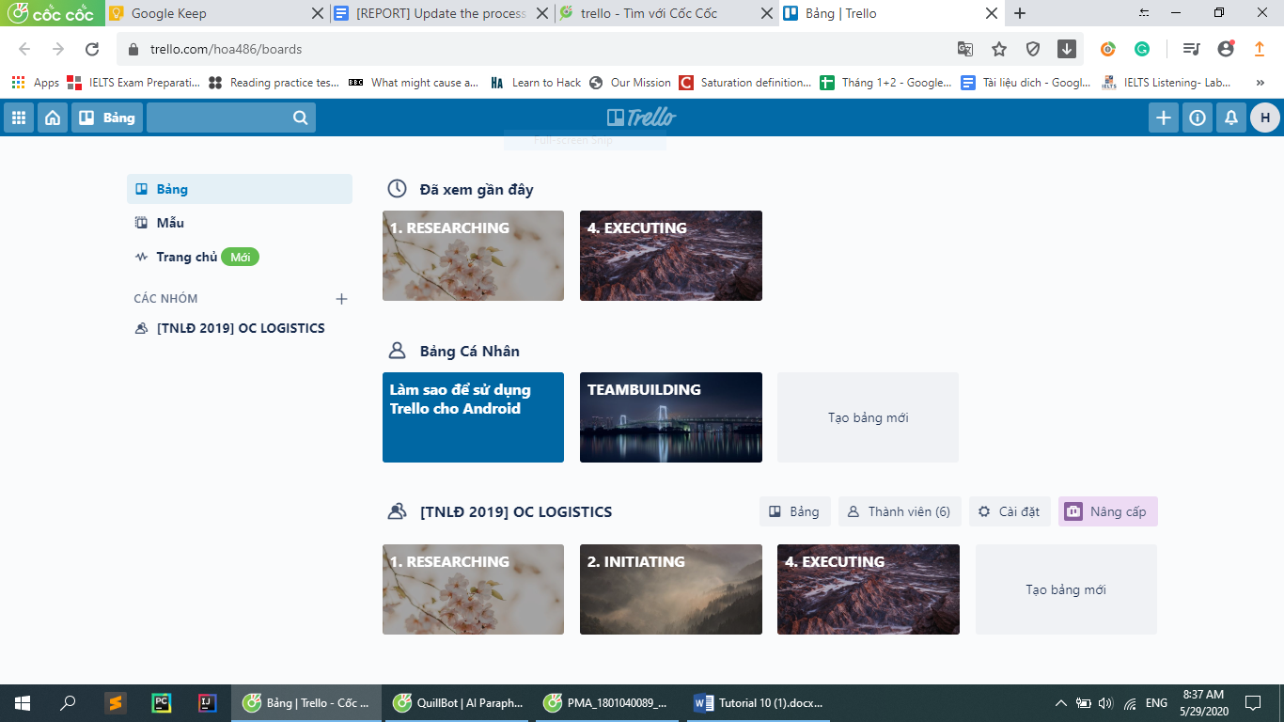

*Figure 1: My own experience of Trello*

I began with Trello when I was a logistic member in a project named “Tài Năng Lãnh Đạo 2019” (TNLĐ 2019). In my opinion, there are many wonderful features in this application. The first thing I want to show that Trello is fairly easy to use and its interface is quite simple. Therefore, I can see the overview of tasks or projects without any trouble. Secondly, Trello gives me a variety of available templates from different fields, so I can reduce my time thinking about the structure of my project or daily tasks. Finally, customization is a great feature in the software. Trello provides plenty of versatility when it comes to tailoring the interface to fit the needs of the team. However, throughout my experience of Trello, I see some noticeable drawbacks of the software. First of all, this project management application is not appropriate for complex tasks due to the limitation of simple descriptions. If you are expecting to write detailed documents for your multiple tasks on your board, Trello might not be the best solution, as you are restricted to a shorter description. The second disadvantages I would like to mention is that Trello sometimes makes users triggered by much manual setup. Repeated procedures like implementations also require a large amount of effort.

After considering pros and cons, I highly recommend that this tool is suitable when we use it for small teams and are assigning tasks to them and keeping track of our team ‘s progress. When the team is getting big then the workload becomes difficult to manage.

# **References**

Aston, B. (2019, October 25). *List Of The 10 Best Communication Tools & Software*. Retrieved from thedigitalprojectmanager.com: <https://thedigitalprojectmanager.com/best-communication-tools/>

BusinessBalls. (2019). *Body Language*. Retrieved from BusinessBalls: <https://www.businessballs.com/self-awareness/body-language/>

Cherry, K. (2019, September 28). *Understanding Body Language and Facial Expressions*. Retrieved from verywellmind: <https://www.verywellmind.com/understand-body-language-and-facial-expressions-4147228>

Duffy, J. (2019, December 18). *The Best Project Management Software for 2020*. Retrieved from PCMag: <https://www.pcmag.com/picks/the-best-project-management-software>

Edwards, V. V. (2017, August 18). *How to Read People’s Eye Direction and Behavior*. Retrieved from Science of People: <https://www.scienceofpeople.com/read-people-eyes/>

examples.yourdictionary.com. (2019). *Examples of Body Language*. Retrieved from Your Dictionary: <https://examples.yourdictionary.com/examples-of-body-language.html>

[financesonline.com](https://examples.yourdictionary.com/examples-of-body-language.html). (2020). *Trello Review*. Retrieved from FinancesOnline: <https://reviews.financesonline.com/p/trello/?category=project-management-software>

[getapp.com](https://reviews.financesonline.com/p/trello/?category=project-management-software). (2020). *monday.com Pricing, Features, Reviews & Comparison of Alternatives*. Retrieved from GetApp: <https://www.getapp.com/collaboration-software/a/monday-com/>

Kubasch, M. (2020). *9 Powerful Collaboration And Communication Tools For Better Project Management*. Retrieved from UK Linkology: <https://www.uklinkology.co.uk/communication-tools-for-project-management/>

Marsan, A. (2015, March 1). *9 Essential Tools for Project Communication*. Retrieved from Atomic Object: [https://spin.atomicobject.com/2015/03/01/project-communication-tools/](%20https:/spin.atomicobject.com/2015/03/01/project-communication-tools/)

Mind Tools Content Team. (2020). *Body Language: Picking Up and Understanding Nonverbal Signals*. Retrieved from MindTools: <https://www.mindtools.com/pages/article/Body_Language.html>

techopedia. (n.d.). *Project Management Software*. Retrieved from techopedia: <https://www.techopedia.com/definition/13132/project-management-software>